PRO. SUM OF INTEGERS

AIM: To implement a prolog program to Sum the Integers from 1 to n.

OBJECTIVES:
- To write a Prolog program that calculates the sum of all integers from 1 to N using recursion.

ALGORITHM:
- Start the program.
- Read the value of N.
- Define the base case: if N = 0, the sum is 0.
- For N > 0, calculate the sum recursively using:
- Sum(N) = N + Sum(N-1)
- Display the calculated sum.
- Stop the program.

SYSTEM-ARCHITECTURE:
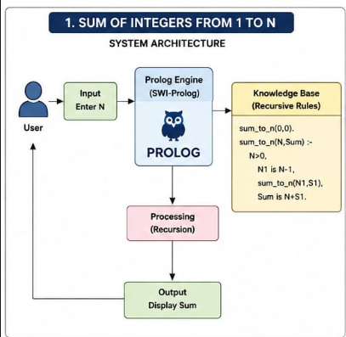

PROGRAM:
% Program to find the sum of integers from 1 to N

% Base case
sum_to_n(0, 0).

% Recursive case
sum_to_n(N, Sum) :-
N > 0,
N1 is N - 1,
sum_to_n(N1, S1),
Sum is N + S1.

% Main predicate
main :-
write('Enter the value of N: '),
read(N),
sum_to_n(N, Sum),
write('Sum of integers from 1 to '),
write(N),
write(' is: '),
write(Sum),
nl.

OUTPUT:
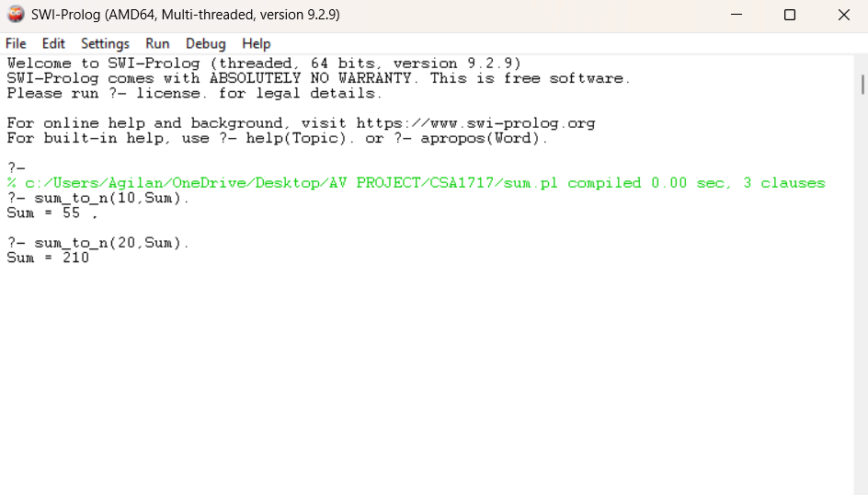

RESULT: Thus the Sum of Integers from 1 to n is implemented successfully using Prolog program.

